* **Languages used:-**

1. Python
2. SQL Query Language

* **Software used:**

1. Anaconda Spyder
2. MySQL
3. Windows of any suitable version

* **Libraries used:-**

1. mysql.connector
2. random
3. matplotlib.pyplot
4. Date and Datetime class of Datetime library

* **Databases used:-**

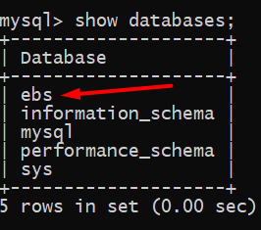

* **Tables in database ebs:-**

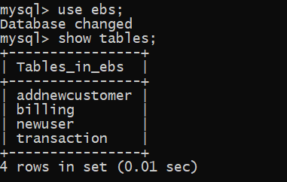

* **Structures of tables:-**

1. **Newuser:**

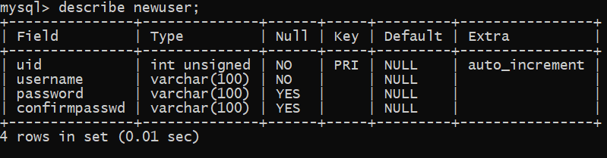

1. 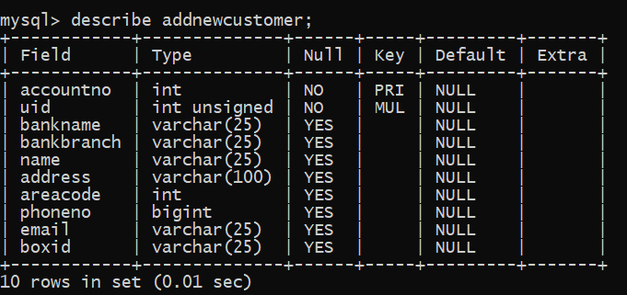 **Addnewcustomer:**

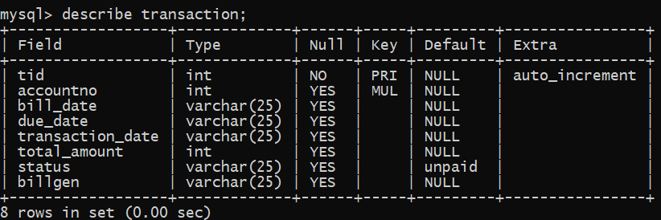**3. Transaction:**

1. **Billing:**

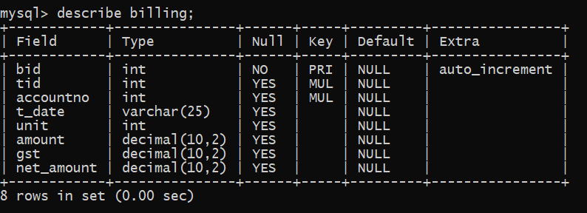

* **Python libraries used:-**

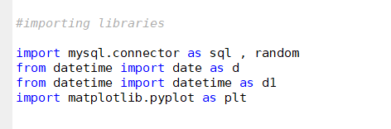

* **Making connection with MySQL:-**

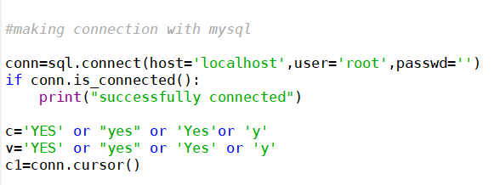

* **Creating tables and database:-**

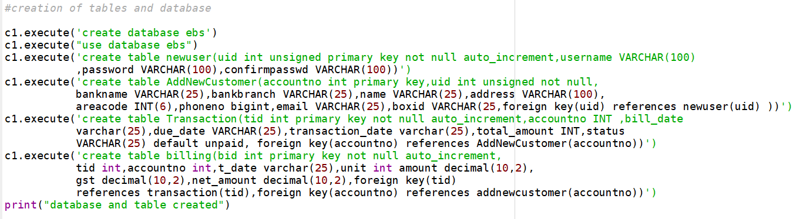

* **Main Menu:-**

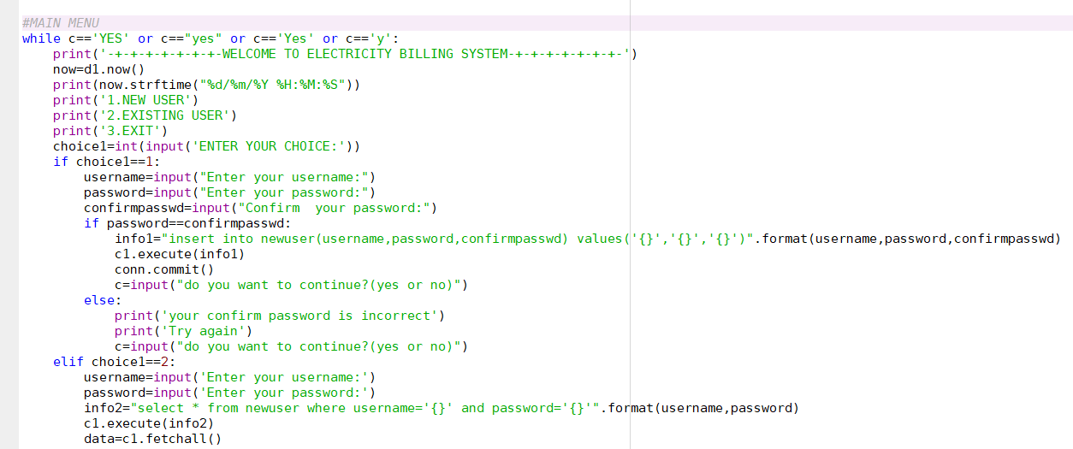

* **Output:-**

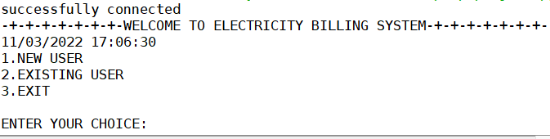

1

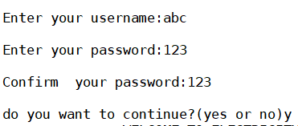

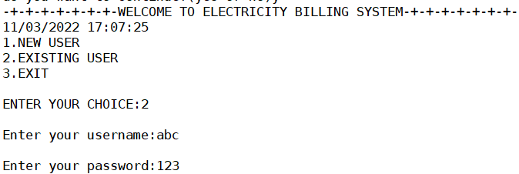

* **Secondary Menu:-**

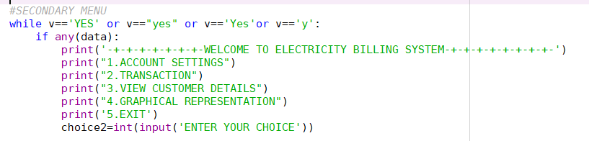

* **Output:-**

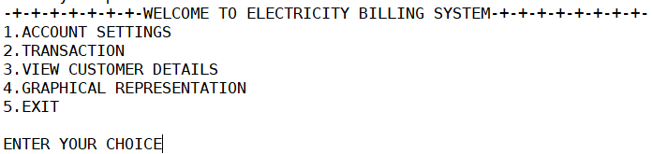

* **User Log in:-**

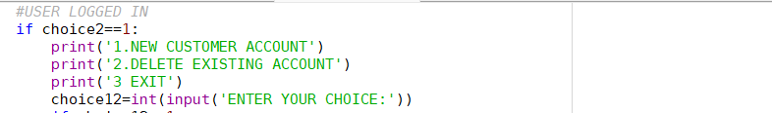

* **Output:-**

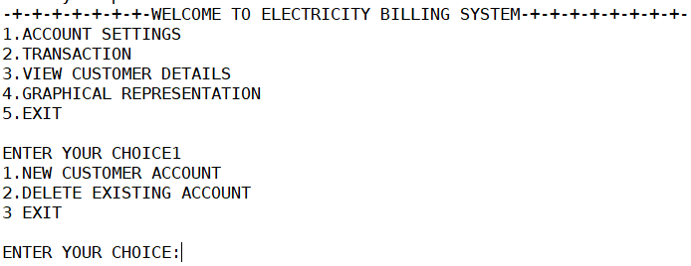

* **New account creation:-**

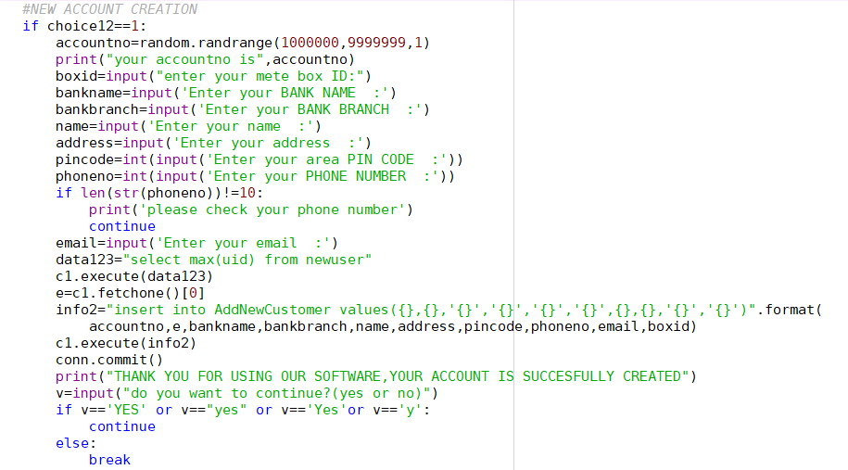

* **Output:-**

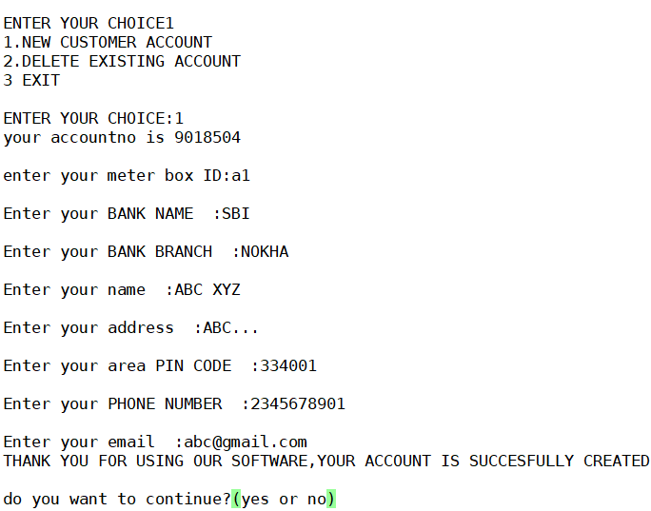

* **Account deletion:-**

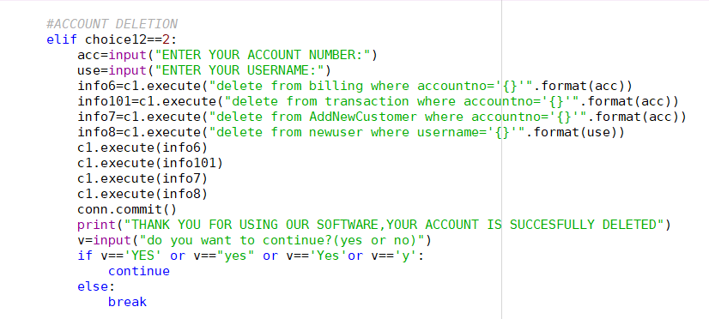

* **Output:-**

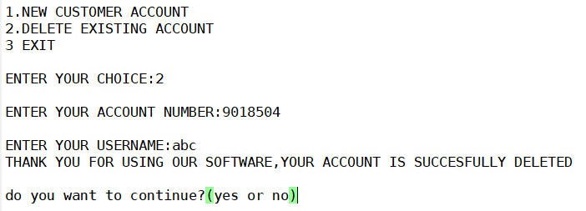

* **Transaction:-**

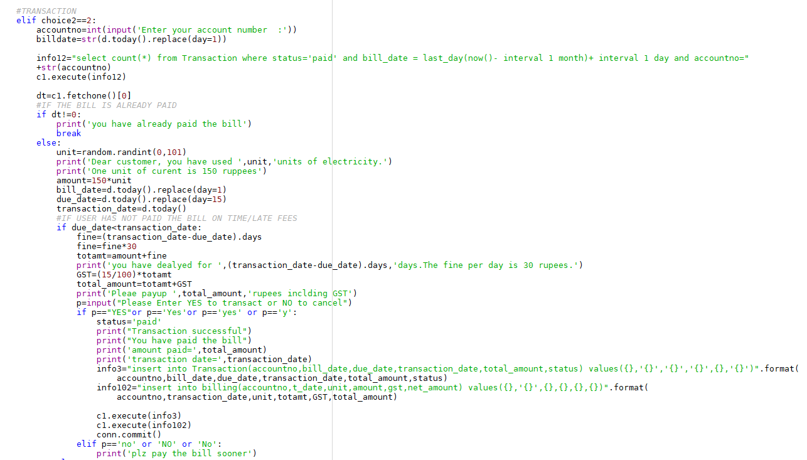

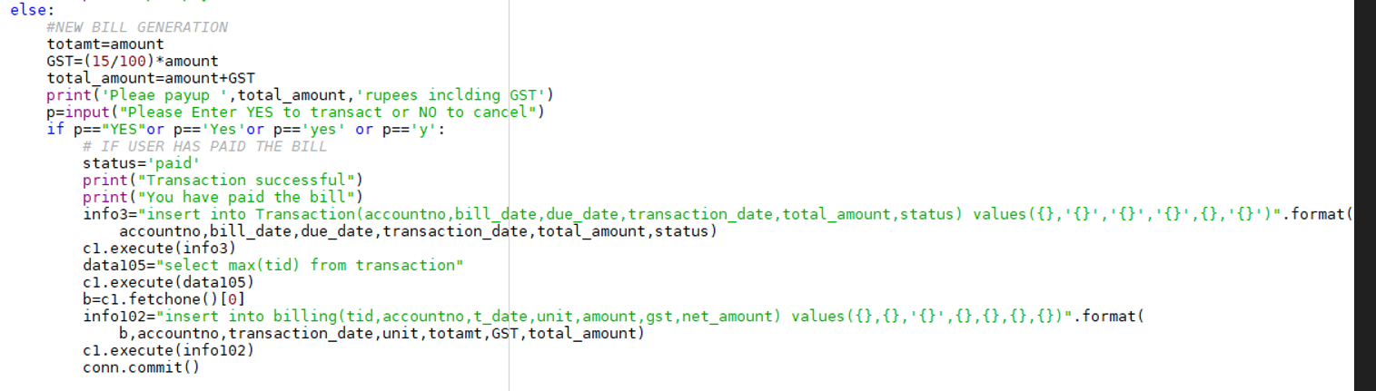

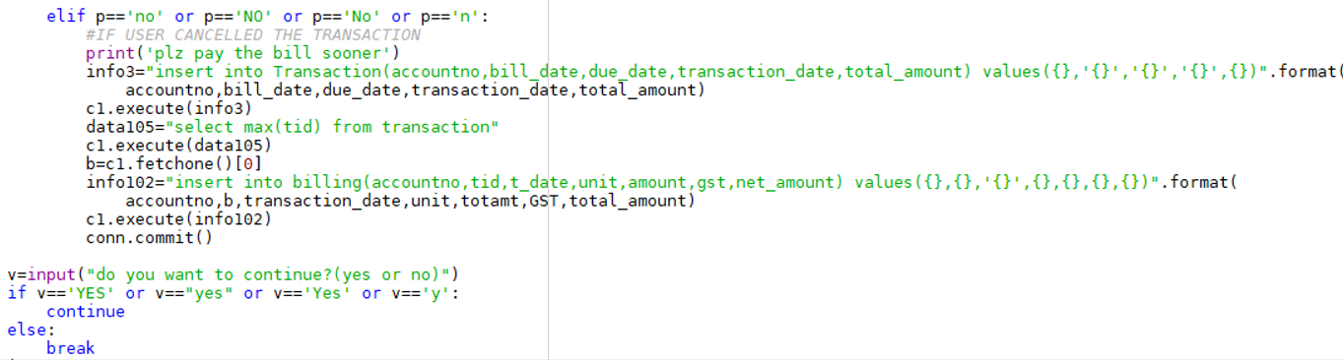

* **Output:-**

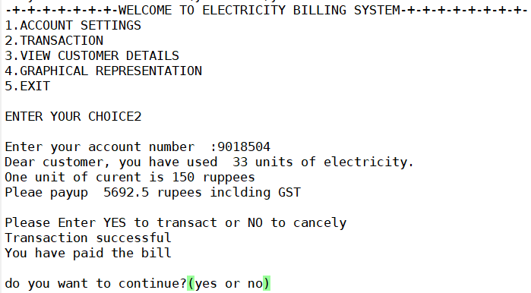

* **Customer details :-**

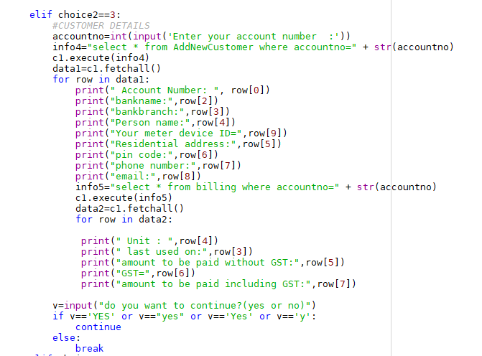



* **Output:-**

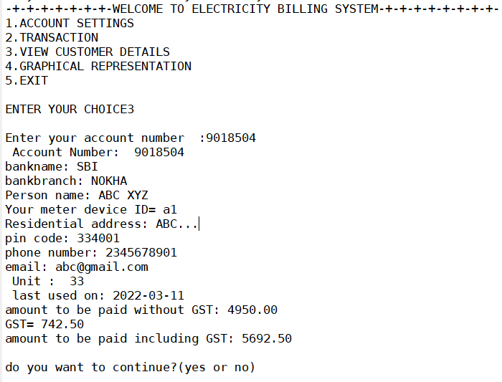

* **Graphical representation of total transactions:-**

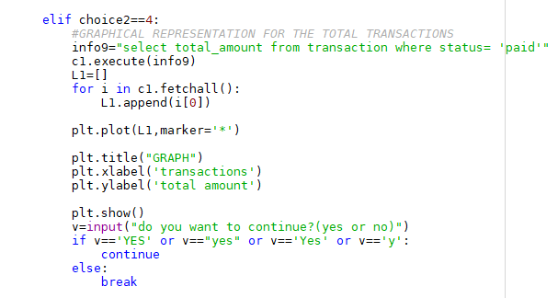

* **Output:-**

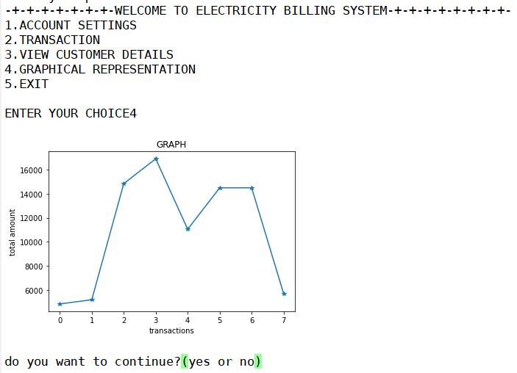

* **Exit from secondary menu:-**

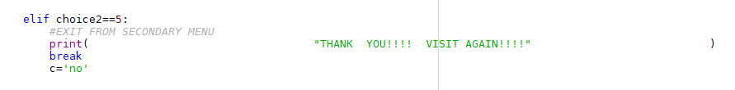

* **Output:-**

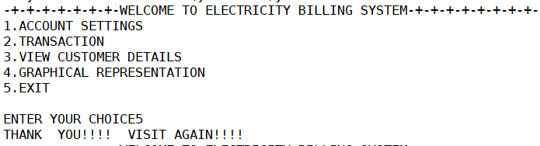

* **If wrong username or password has been entered:-**

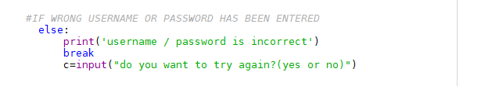

* **Output:-**

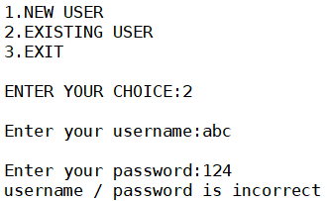

* **To exit from main menu:-**

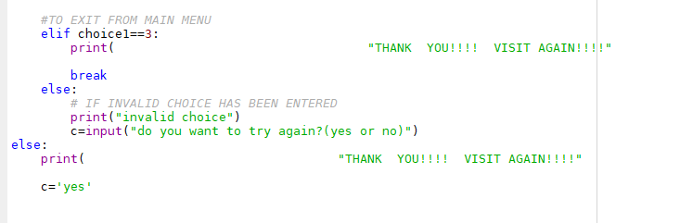

* **Output:-**

